**Lincoln Weekly Mock Test**

Date – 17/08/2022

Writing

Candidate Name= …………. Candidate Number=……………

Candidate signature=………………

Task 1

You should spend about 20 minutes on this task.

The maps below show the centre of a small town called Islip as it is now, and plans for its development.

Summarise the information by selecting and reporting the main features, and make comparisons where relevant.

Write at least 150 words.

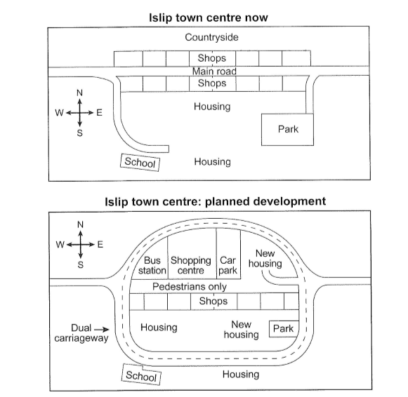

## Task 2

WRITING TASK 2

You should spend about 40 minutes on this task. Write about the following topic:

## In a number of countries, some people think it is necessary to spend large sums of money on constructing new railway lines for very fast trains between cities. Others believe the money should be spent on improving existing public transport.

Discuss both these views and give your own opinion.

Give reasons for your answer and include any relevant examples from your own knowledge or experience.

Write at least 250 words.